Name Date

Concepts 1 - 5

Unit 1 Review

_____________________________________________________________________________________________

**Concept 1 - Integer Operations: Simplify the Expression**

1. $-14+9$**2. $-5-6$**
2. $-5(-8)$ 4. $36÷(-6)$

____________________________________________________________________________

**Concept 2 - Order of Operations: Simplify the Expression if $a=-3, b=4, and c=12$**

**5. $a+c÷b-a$** **6. $b^{2}+a^{2}-c$**

____________________________________________________________________________

Concept 3 – Rational Numbers

7. Convert into a mixed number $-4.26$

**8.** Convert into a decimal: $\frac{3}{8}$

**Concept 4 – Adding & Subtracting Rational Numbers**

**9.**  **10. $3\frac{1}{3}-4\frac{5}{6}$**

**11. $-9.24+2.89$**  **12**. $-13.6-2.754$

____________________________________________________________________________

**Concept 5 – Multiplying & Dividing Rational Numbers**

**13.**  **14. $-4\frac{2}{3}÷2\frac{1}{6}$**

**15.**  **16. $-4.2÷-12$**

**Application – Are you really ready?!?**

**17.** The following table shows the amount of strokes, above / below par, in half a game of golf.   
 What is the golfer’s score?

|  |  |  |  |  |  |  |  |  |  |
| --- | --- | --- | --- | --- | --- | --- | --- | --- | --- |
| Hole | 1 | 2 | 3 | 4 | 5 | 6 | 7 | 8 | 9 |
| Score | 0 | -1 | 2 | -2 | 0 | 1 | -1 | 0 | -1 |

**18.** Sarah has a jumbo piece of licorice. It is 8 feet long! Sarah decides to share her licorice   
 with some friends. She gives Adam $1\frac{1}{2}$ feet, Michelle $2\frac{3}{4}$ feet and Kim $1\frac{5}{6}$ feet. How much   
 licorice does Sarah have left over for herself?

**19.** How manypackages of peanuts can be made with 8 ounces of peanuts?

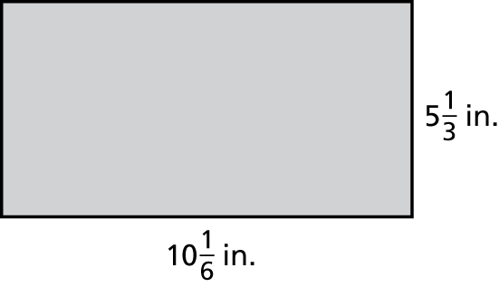

20. Find the area of the rectangle (Area = Length x Width):